**KALLAM HARANADHAREDDY INSTITUTE OF TECHNOLOGY**

**(AUTONOMOUS)**

**DEPARTMENT OF INFORMATION TECHNOLOGY**

**TITILE: FIELD SERVICE WORK ORDER OPTIMIZATION**

**UNDER THE ESTEEMED GUIDENCE OF**

**SALESFORCE AI DEVELOPER**

**SUBMITTED BY**

**M. SHARON PUSHPA**

[**218x1a1221@khitguntur.ac.in**](mailto:218x1a1221@khitguntur.ac.in)

**B. YOGA PRIYA**

[**218x1a1249@khitguntur.ac.in**](mailto:218x1a1249@khitguntur.ac.in)

**K. VARUN KUMAR**

[**218x1a1256@khitguntur.ac.in**](mailto:218x1a1256@khitguntur.ac.in)

**D. MANIKANTA REDDY**

[**218x1a1251@khitguntur.ac.in**](mailto:218x1a1251@khitguntur.ac.in)

**Project Overview**

The Field Service Work Order Optimization System revolutionizes operations for companies specializing in installations and repairs. By utilizing a comprehensive database, the system adeptly matches work orders with the most suitable technicians, based on their location, availability, and skill sets. This sophisticated algorithm ensures tasks are assigned efficiently, minimizing downtime and maximizing productivity. Automated communication features keep technicians well-informed with real-time notifications about assignments, changes, and updates. Meanwhile, analytics offer valuable insights into technician performance and customer satisfaction, driving continuous improvement. Ultimately, this solution enhances operational efficiency, reduces costs, and significantly boosts customer satisfaction in the dynamic field of service operations.

**Objectives**

**1.Bussiness Goals:**

Salesforce helps organizations streamline operations, improve customer relationships, and drive business growth. Here are key business goals that can be achieved using Salesforce.

**1. Increase Sales & Revenue:**

Lead & Opportunity Management – Track and convert leads efficiently.

Sales Automation – Reduce manual tasks and improve productivity.

AI-Driven Forecasting – Predict sales trends and optimize strategies.

**2. Enhance Customer Satisfaction & Retention:**

Omni channel Customer Support – Provide seamless service across email, chat, phone, and social media.

Personalized Customer Journeys – Use AI-driven insights to tailor interactions.

**3. Improve Marketing Effectiveness:**

Targeted Campaigns – Segment of audiences for personalized marketing.

Marketing Automation – Email marketing, social media, & lead nurturing.

Performance Analytics – Measure and optimize campaign success.

**4. Streamline Business Operations:**

Process Automation – Reduce manual workflows with Salesforce Flow & Process Builder.

Data Integration – Connect Salesforce with other business systems (ERP, HR, Finance).

Custom App Development – Build tailored solutions using the Lightning Platform.

**5. Foster Data-Driven Decision Making:**

Real-Time Dashboards & Reports – Gain insights into business performance.

AI-Powered Analytics – Use Einstein AI for predictive insights and trends.

Centralized Data Management – Ensure data consistency and accuracy.

**2. Business Outcomes:**

Implementing Salesforce drives measurable business outcomes across sales, customer service, marketing, and overall operations. Here are the key business outcomes organizations.

**1.Increased Sales & Revenue:**

Higher conversion rates through effective lead and opportunity management.

Shorter sales cycles due to automation and AI-driven forecasting.

Improved upselling and cross-selling with customer insights and analytics.

**2. Enhanced Customer Satisfaction & Retention:**

Faster response times with AI-driven case management and self-service portals.

Personalized customer experiences with Einstein AI and Marketing Cloud.

Stronger relationships through 360-degree customer visibility.

**3. Improved Operational Efficiency:**

Automation of repetitive tasks, reducing manual workload and errors.

Seamless data integration across departments for better collaboration.

Real-time analytics for proactive decision-making.

**4. Optimized Marketing Performance:**

Higher engagement rates from targeted campaigns and personalization.

Better ROI tracking with real-time marketing analytics.

Increased lead generation through automated and AI-enhanced marketing strategies.

**5. Stronger Security & Compliance:**

Reduced risk of data breaches with role-based access control and encryption.

Compliance with industry regulations like GDPR, HIPAA, and ISO.

Enhanced security with Multi-Factor Authentication (MFA).

**Salesforce Key Features And Concepts Utilized**

**Key Features Of Salesforce:**

1. Customer Relationship Management (CRM)

2. Sales Automation (Sales Cloud)

3. Customer Service & Support (Service Cloud)

4. Marketing Automation (Marketing Cloud)

5. Customization & App Development

**Key Concepts Utilized in Salesforce:**

1. Data Model & Structure

2. Security & Access Control

3. Integration & Connectivity

4. Automation & Process Management

5. Customization & Development

**Detailed Steps to Solution Design**

**Sales force:**

Relating the Sales force Developer Edition org allows developers to experiment, innovate, and build customized solutions within a controlled environment. With access to Sales force's powerful development tools and features, developers can prototype, test, and refine their applications, empowering them to deliver robust and tailored solutions to meet unique business requirements.

**Account Activation:**

1. Go to the inbox of the email that you used while signing up. Click on the verify account to activate your account. The email may take 5-10mins.

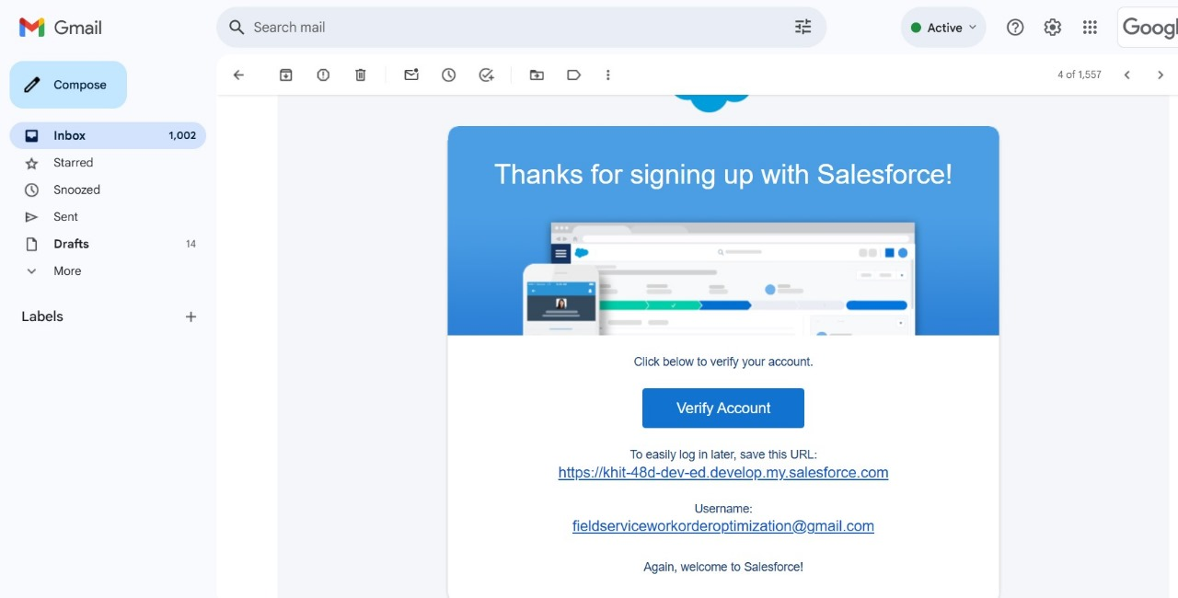

2. Click on Verify Account

3. Give a password and answer a security question and click on change password

4. Then you will redirect to your sales force setup page.

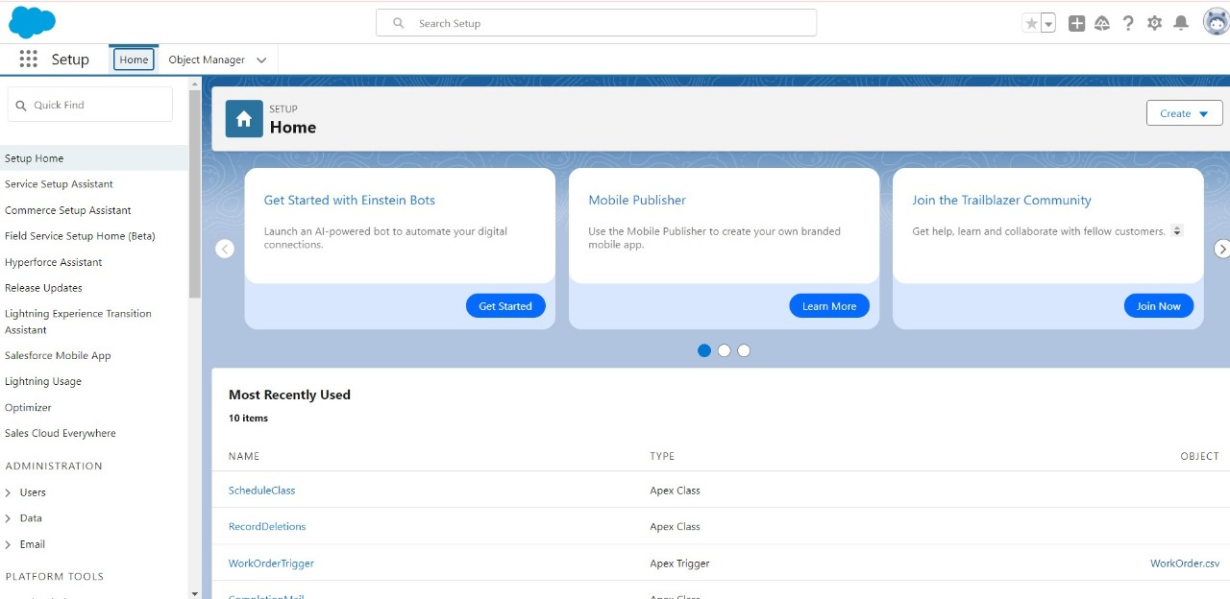

**Object:** To store the data as per business requirement.

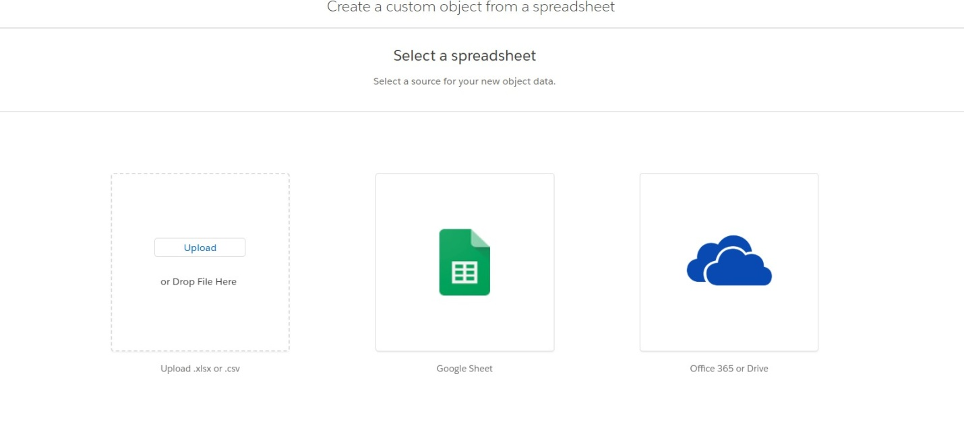

### Create Technician Object:

### WhatsApp Image 2025-03-04 at 12.29.45 PM (2).jpeg

### Create Work Order Object:

### WhatsApp Image 2025-03-04 at 12.39.24 PM.jpeg

### Create Assignment Object:

To create an object:

1. From the setup page --> Click on Object Manager --> Click on Create Click on Custom Object.

1. Enter the label name --> Assignment

2. Plural label name --> Assignments

### WhatsApp Image 2025-03-04 at 12.39.31 PM.jpeg

3. Enter Record Name Label and Format

Record Name --> Assignment ID

Data Type --> Auto Number

Display Format --> A-{0000}

Starting Number --> 1

4. Click on Allow reports,

### Allow search --> Save.

### Tabs:

### A tab is like a user interface that is used to build records for objects and to view the records in the objects.

### Creating a Custom Tab:

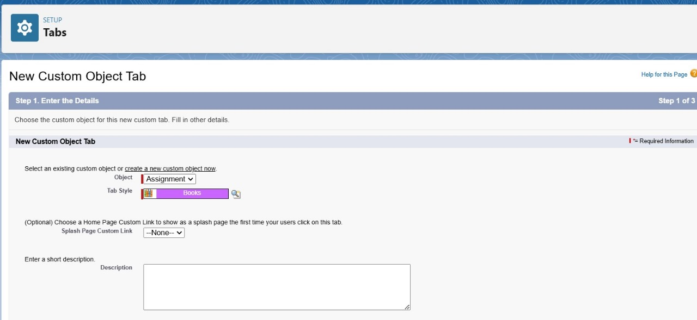

**The Lightning App:**

Well done you have reached close to your organizational requirement by creating the objects to store the organization’s data. Making a database for an organization is just not enough to reach out the requirements, the task is how the users at the organization can access the objects you have created for them.

**Create a Lightning App:**

To create a lightning app page:

1. Go to setup page --> search “app manager” in quick find --> select “app manager”

--> click on New lightning App.

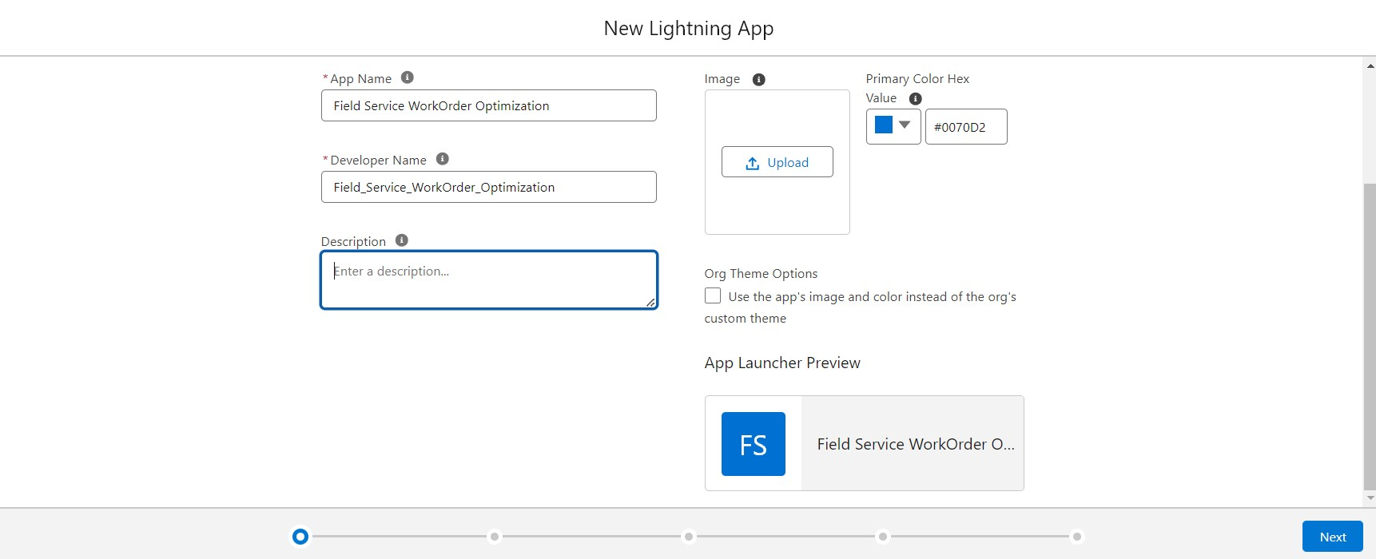

2. Fill the app name in app details and branding as follow  
App Name: Field Service Work Order Optimization  
Developer Name: this will auto populated  
Description: Give a meaningful description  
Image: optional (if you want to give any image you can otherwise not mandatory)  
Primary color hex value: keep this default.

3. Then click Next  --> (App option page) keep it as default --> Next --> (Utility Items) keep it as default --> Next.

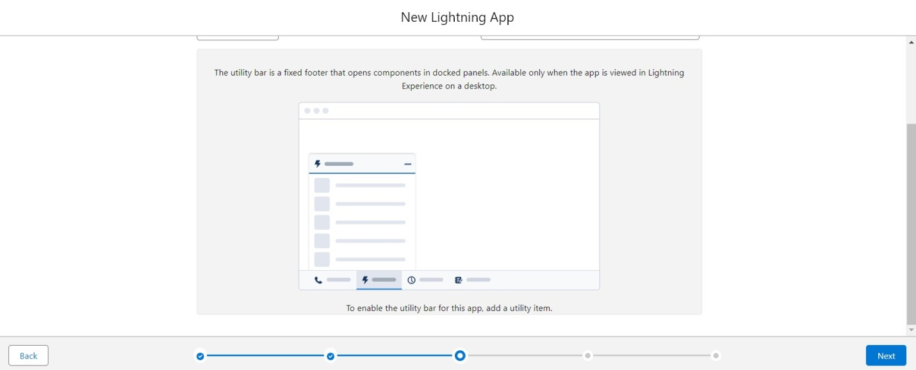

4. To Add Navigation Items:

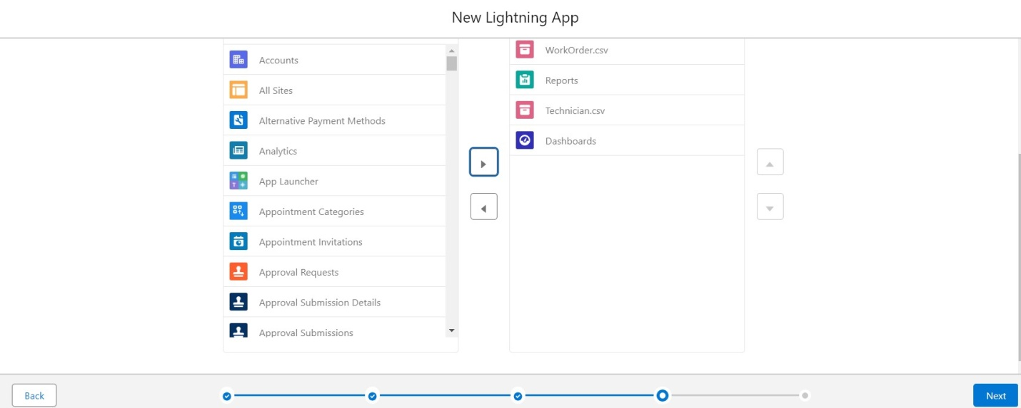

Search the items in the search bar (Home, Work Order, Technician, Assignment, Reports, Dashboard) from the search bar and move it using the arrow button.  
Note: select asset the custom object which we have created in the page.  
5. To Add User Profiles

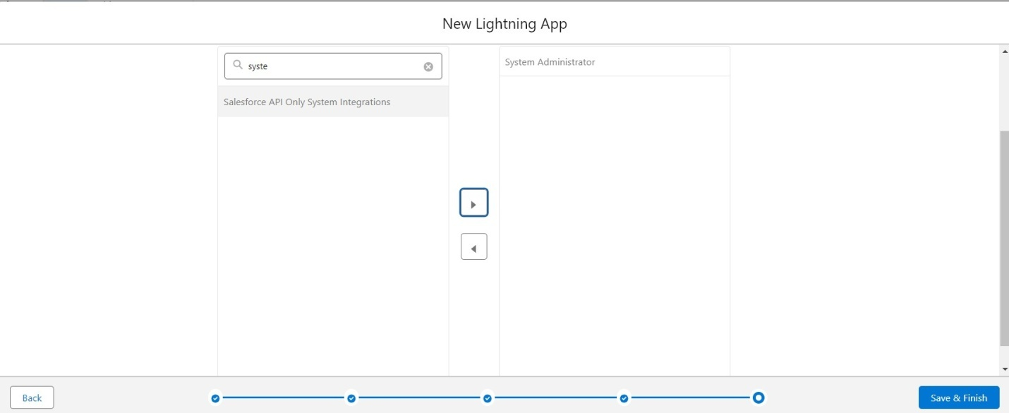

Search profiles (System administrator) in the search bar --> click on the arrow

button --> save & finish.

**Fields & Relationship:**

Now it’s time for you to think out of the box for your organization. You have successfully created the database objects for the organization but now all eyes turn on you as you have to define what sort of information the objects store which you have created. As a life saver of your organization you come up with the idea of creating fields to store different types of data.

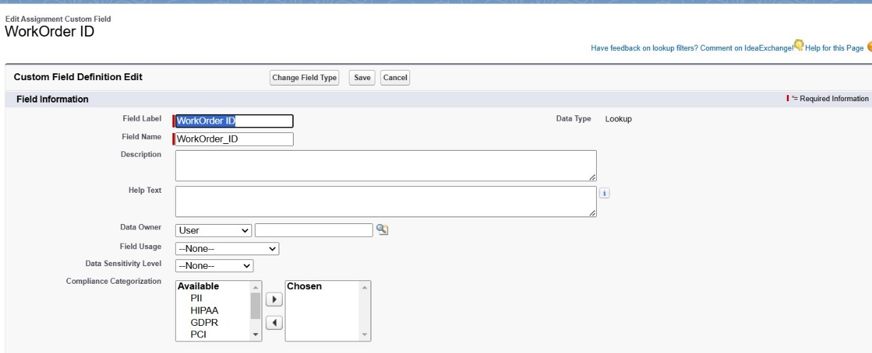

### Creating Lookup Field in Assignment Object:

To create fields in an object:

1. Go to setup --> click on Object Manager --> type object name (Assignment) in quick find bar--> click on the object.

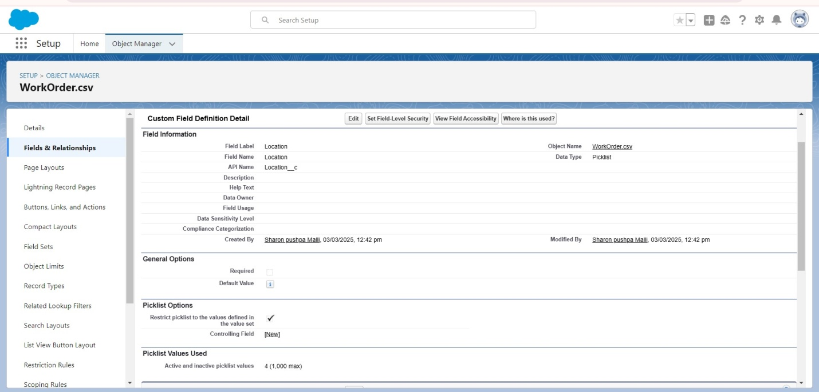

1. Now click on “Fields & Relationships” --> New
2. Select Data type as “Lookup”
3. Click on Next

5. For field label related to: select “Work Order” object and click Next

6. Give Field Label as “Work Order ID” and click Next  
7. Next --> Next --> Save & New

**Manage your picklist values:**

1. The setup page go to object manager
2. Search and Select Work Order object
3. Go to fields & relationship, select Location field, scroll down to values and click “New”.

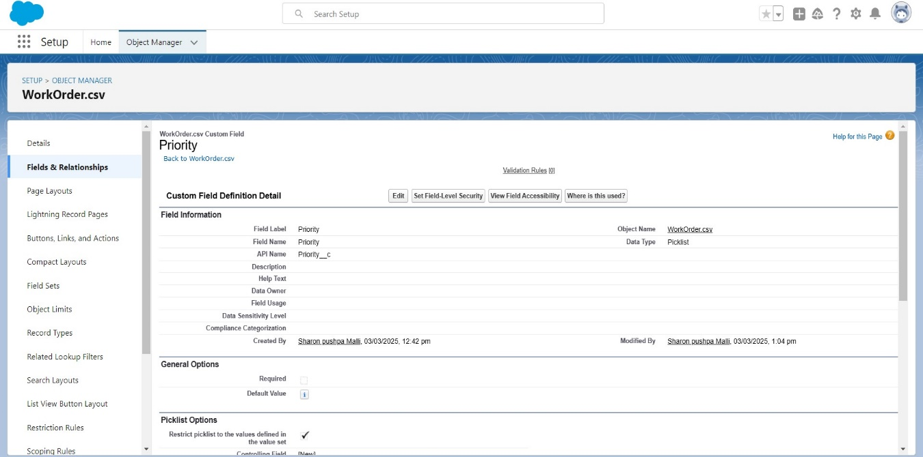

4. Add the below values.

* 1. Click Save.

### Creating Formula Field in Work Order Object:

1. Repeat step 1 and 2 mentioned in activity 1

2. Select Data type as “Formula” and click Next.

3. Give Field Label and Field Name as “Date” and select formula.

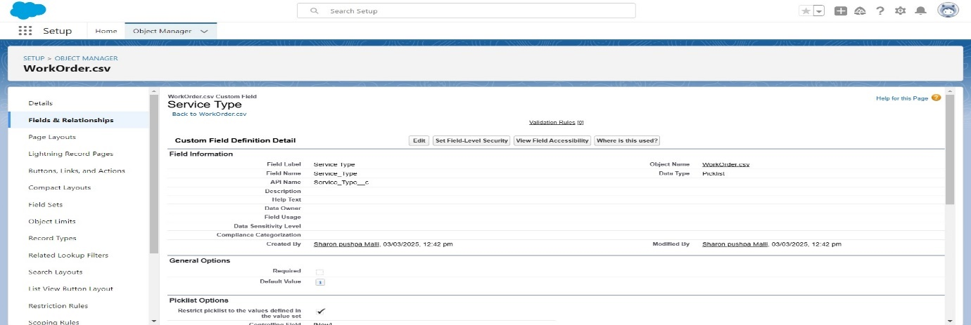

1. Under Advanced Formula write down the formula and click “Check Syntax”  
   formula: Created date

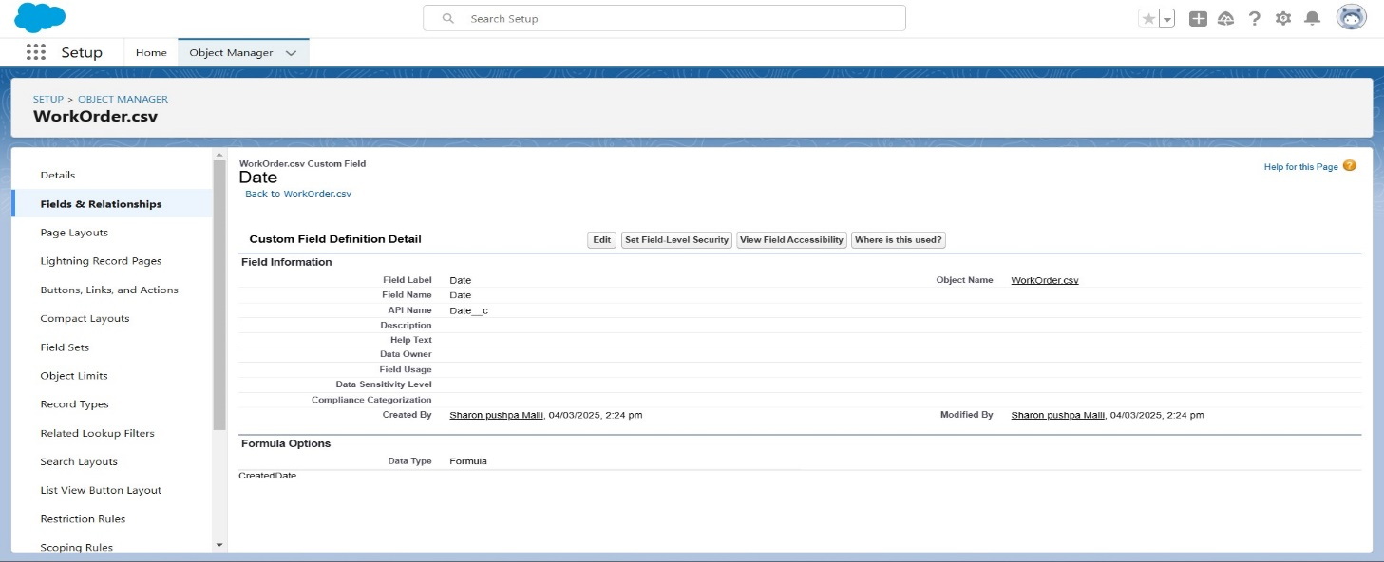

1. Next--> Next--> Save.

### Creating Remaining fields for the respective objects:

Technician Id: Lookup (Technician)

Formula: return type: Date  
(Work Order id Date)

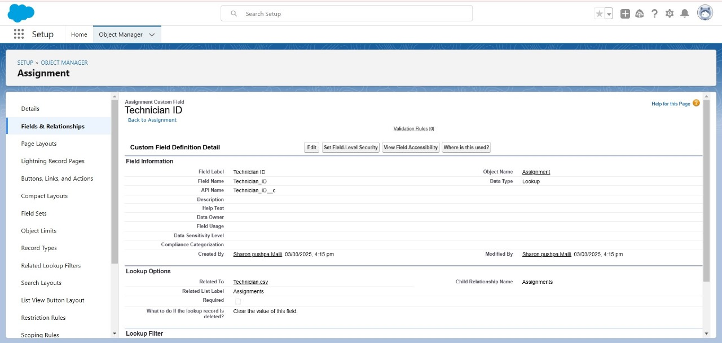

### Assignment Date: Formula: return type: Date IF (IS PICK VAL(Work Order ID r. Status c , 'Resolved')C:\Users\Lalitha Priya\Downloads\sales19 (1).jpg

Completion Date: Work Order ID r. Last Modified Date, NULL.

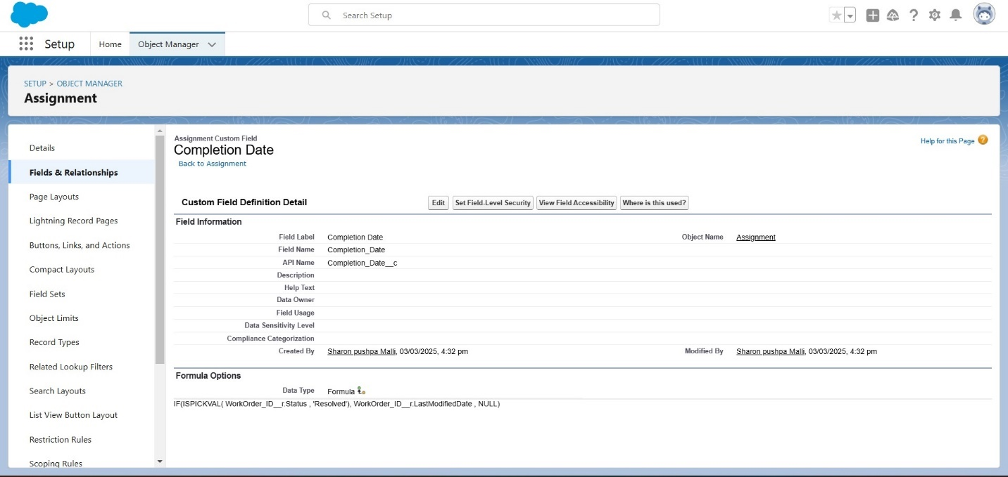

**Profiles:**

Profile defines what an user is able to do or see in the Salesforce Org.

### Technician Profile:

### 1. Go to setup --> type profiles in quick find box --> click on profiles --> click on new profile.

### 2. Select ‘Standard Platform User’ for existing profile and give ‘Technician’ for Profile Name and click on Save.

### Clone Profiles:

1. While still on the profile page, then click Edit.
2. Scroll down to Custom Object Permissions and Give Read only access permissions for Technician, Work Order and Assignment objects and field
3. down and Click on Save.
4. Now from the profile detail page scroll down to custom field level security click on view next to Work Order object.
5. Click on Edit, enable the check box for the status field.

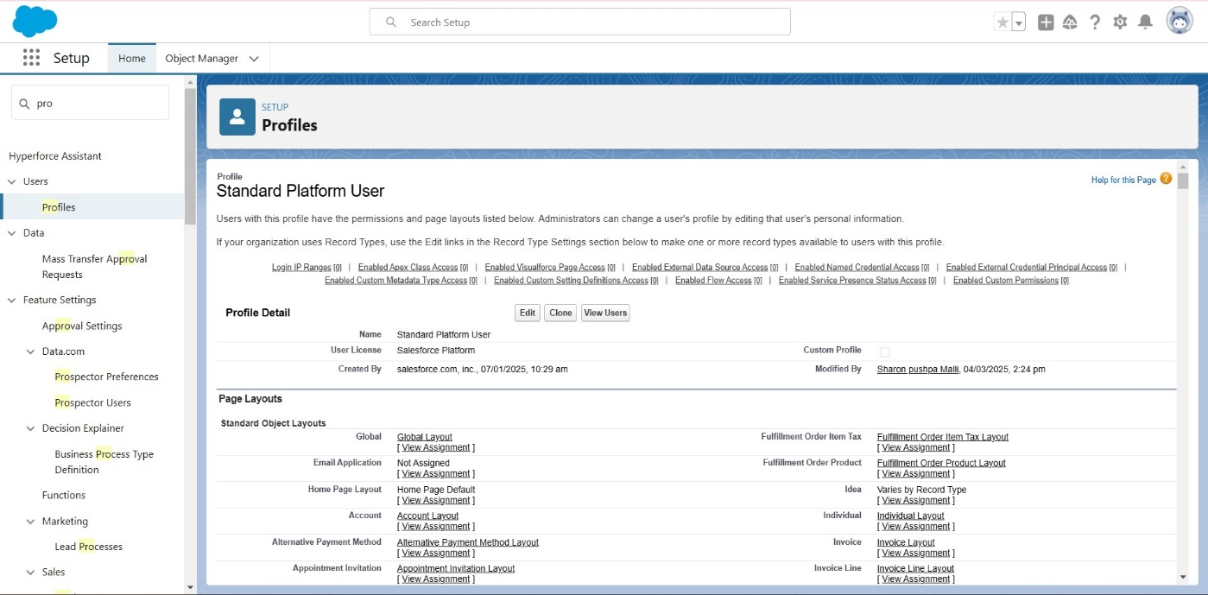

1. Click on Save.

### Users:

Users are defined as the employees of your organization

**Create User:**

1. Go to setup --> type users in quick find box --> select users --> click New us
2. Fill in the fields
3. First Name: Elina
4. Last Name: Gilbert
5. Alias: Give alias Name
6. Email id: Give your Personal Email id
7. Username: Username should be in this form: text@ text .text
8. Nick Name: Give a Nickname
9. User license: Salesforce Platform
10. Profiles: Technician.

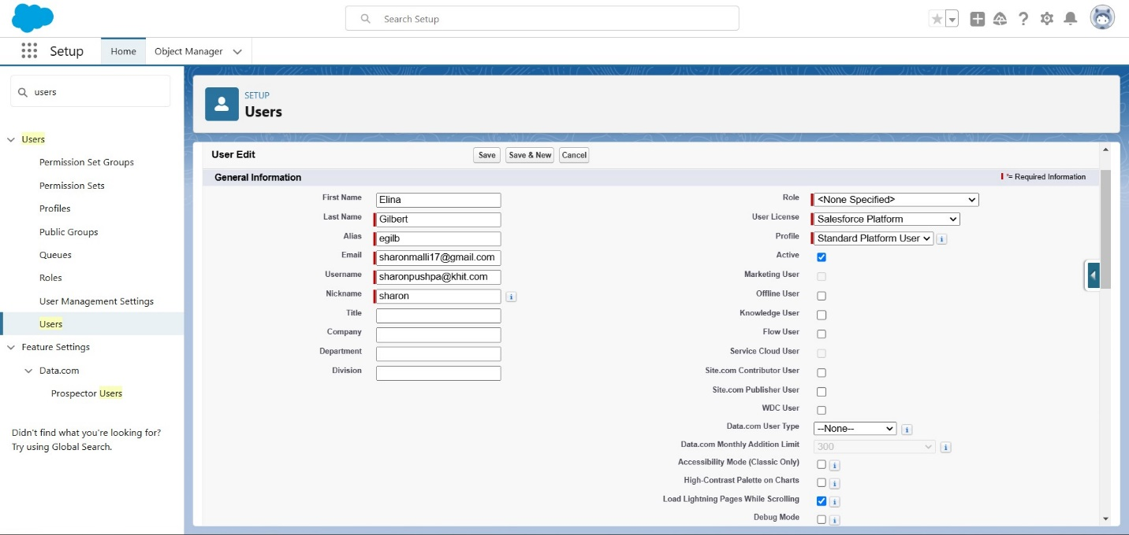

### Apex Trigger:

### Create an Apex Class:

### 1.Go to Setup --> Click on the gear icon --> Select Developer Console.

2.Then we can see the Developer console. Click on the developer console and you will navigate to a new console window.

3.To create a new Apex Class follow the below steps:  
Click on the file --> New --> Apex Class.  
Give the Apex Class name as “Work Order Class”.  
4.Click ok.

5.Now write the code logic here

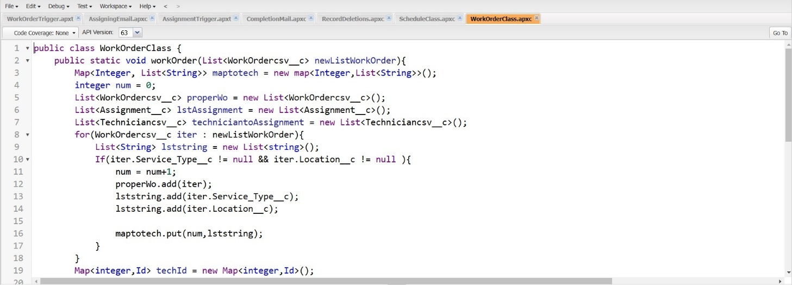

6.Save the code (click on file --> Save)

**Create an Apex Trigger:**

To create a new Apex Class follow the below steps:  
Click on the file --> New --> Apex Class.

1. Give the Apex Trigger name as “Work Order Trigger”, and select “Work Order c” from the dropdown for Object.
2. Click Submit.
3. Now write the code logic here.

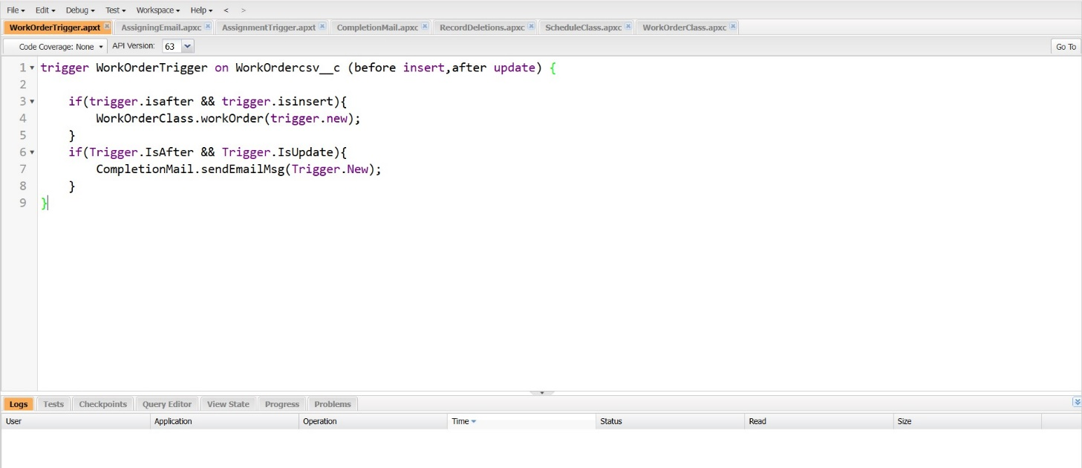

1. Save the code (click on file --> Save)

### Create an Apex Class:

### Go to Setup --> Click on the gear icon --> Select Developer Console.

1. Then we can see the Developer console. Click on the developer console and you will navigate to a new console window.
2. To create a new Apex Class follow the below steps:  
   Click on the file --> New --> Apex Class.
3. Give the Apex Class name as “Assigning Email”.
4. Click ok.

5. Now write the code logic here

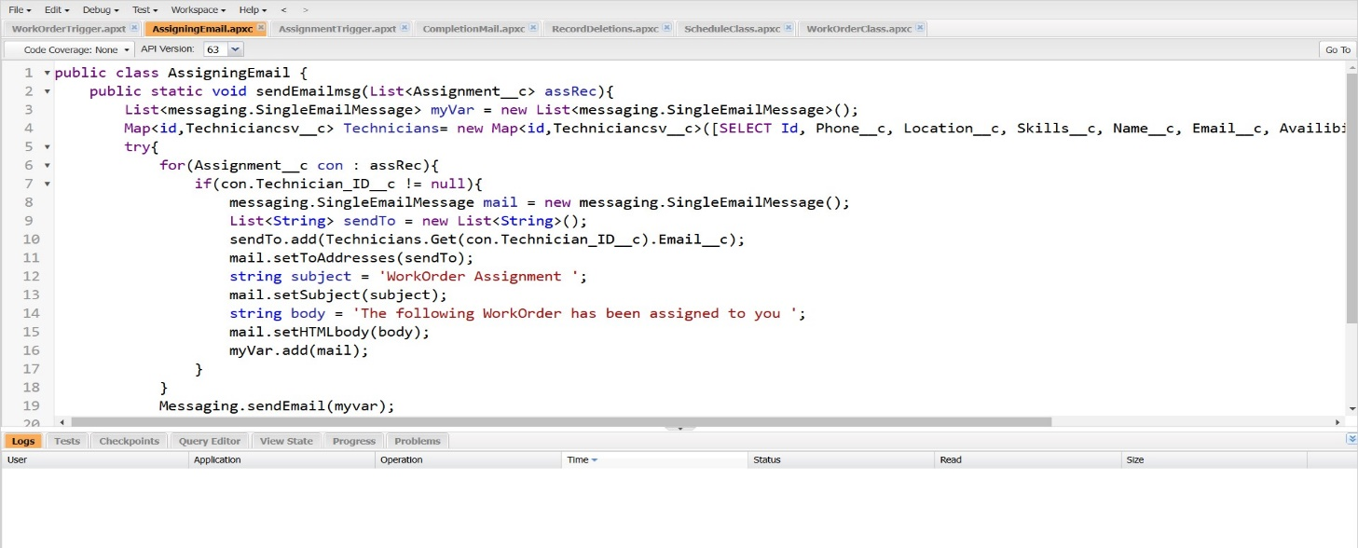

### Create an Apex Trigger:

To create a new Apex Class follow the below steps:  
1. Click on the file --> New --> Apex Class.

2.Give the Apex Trigger name as “Assignment Trigger”, and select “Assignment c” from the dropdown for Object.

3.Click Submit

4.Now write the code logic here

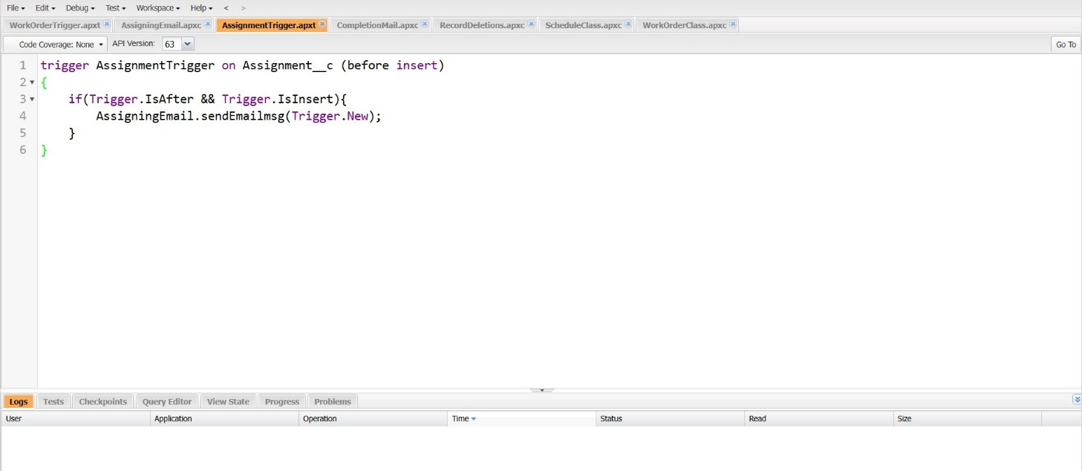

5.Save the code. (click on file --> Save)

**Create an Apex Class:**

1. Go to Setup --> Click on the gear icon --> Select Developer Console.

2.Then we can see the Developer console. Click on the developer console and you will navigate to a new console window.

3.To create a new Apex Class follow the below steps:  
Click on the file --> New --> Apex Class.

4.Give the Apex Class name as “Completion Mail”.

5.Click ok.

6.Now write the code logic here

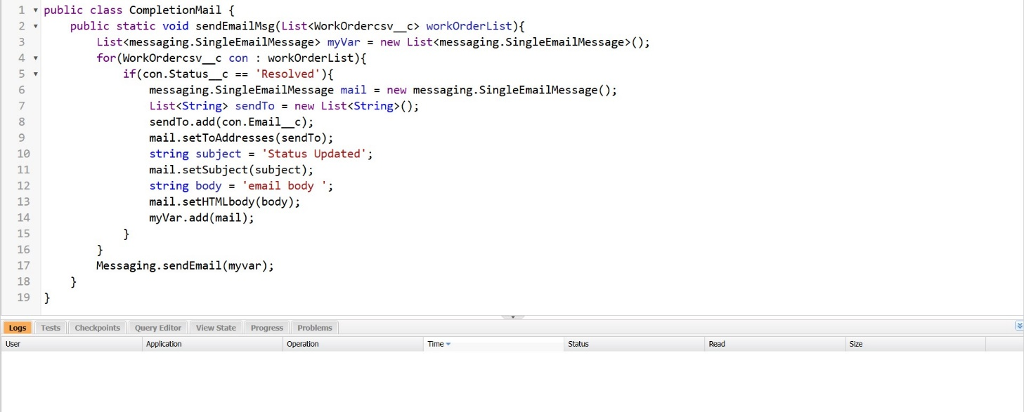

7.Save the code. (click on file --> Save)

### Create an Apex Trigger:

### 1.Click on the file --> Open

### 2.A pop up window opens click on Triggers, then select “Work Order Trigger” and click on “Open”

### 3.Now write the code logic here.

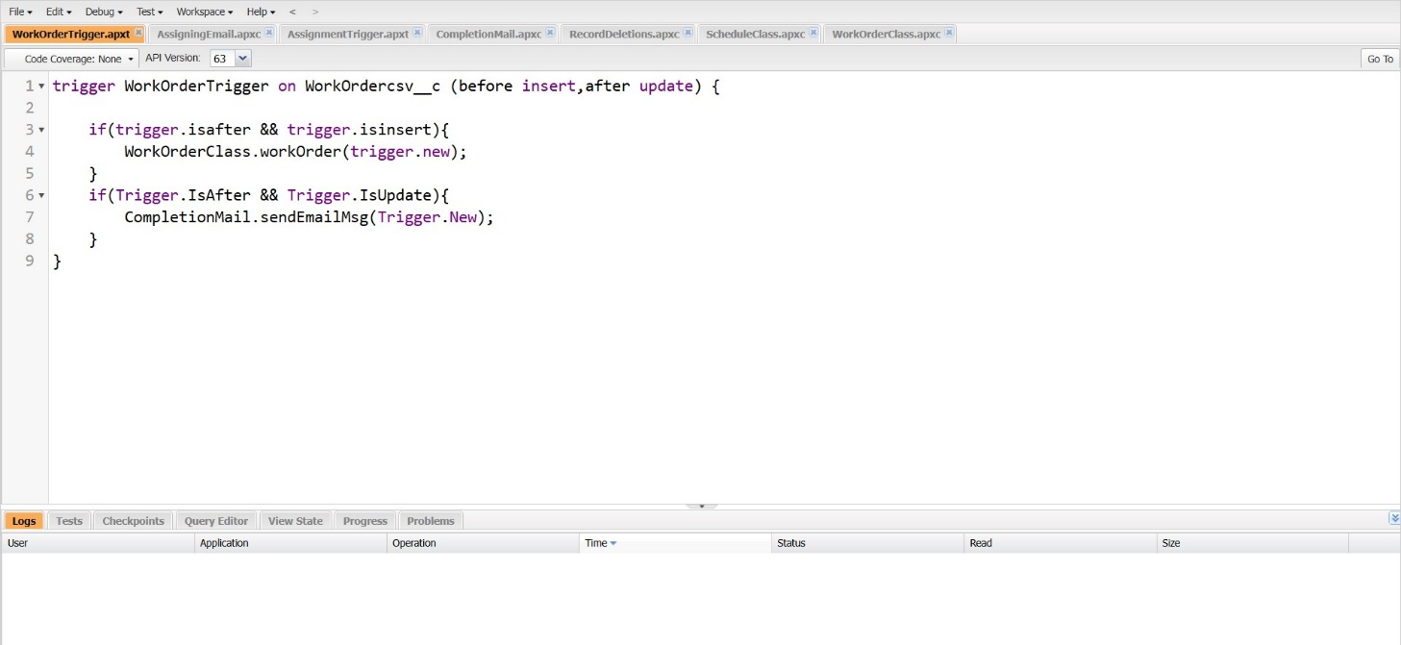

4.Save the code. (click on file --> Save)

### Create an Asynchronous Apex Class:

Create an Apex Class to Delete all the Work Order records which meets the following criteria.

1. Completed date should be more than 30 days.
2. Status should be ‘Resolved’.

## Create an Apex Class

1. Go to Setup --> Click on the gear icon --> Select Developer Console.2.
2. Then we can see the Developer console. Click on the developer console and you will navigate to a new console window.3.
3. Then create a new Apex Class follow the below steps:  
   Click on the file --> New --> Apex Class.

4. Give the Apex Class name as “Record Deletion”.

5. Click ok.

6. Now write the code logic here.

7. Save the code. (click on file --> Save)

### Create an Apex Schedule Class:

### Go to Setup --> Click on the gear icon --> Select Developer Console.

### Then we can see the Developer console. Click on the developer console and you will navigate to a new console window.

1. To create a new Apex class follow the below steps:  
   Click on the file --> New --> Apex Class.
2. Give the Apex Class name as “Schedule Class”.
3. Click ok
4. Now write the code logic here

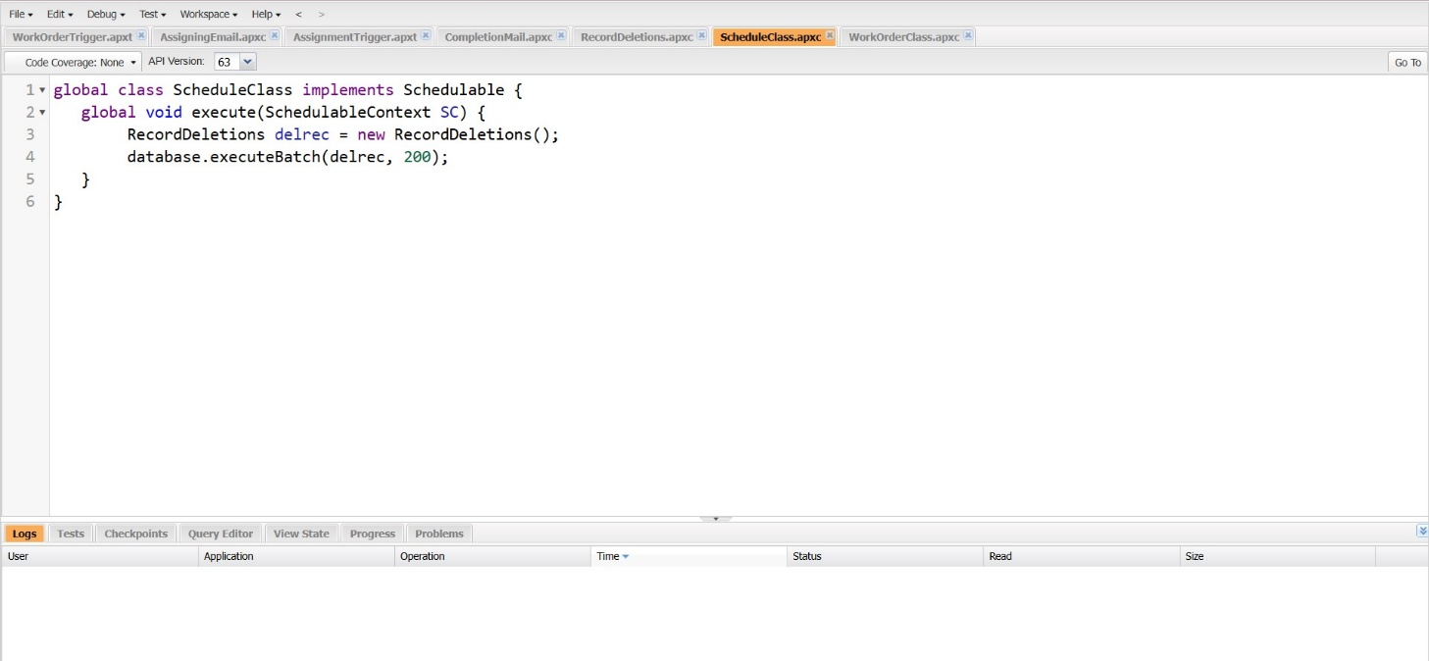

1. Save the code. (click on file & Save)

### Create a Schedule Apex:

Schedule the Apex class:

1. From the Setup page search for “Apex Classes” in quick search.
2. Click on “Schedule Apex” as shown below.3.
3. Click on Schedule Apex and enter the Job name.

a. Job Name: Delete Assignment Schedule

b. Apex Class: Schedule Class (from clicking on lookup icon)

c. Frequency: Monthly

d. Preferred Start Time: Select any time

1. Click Ok

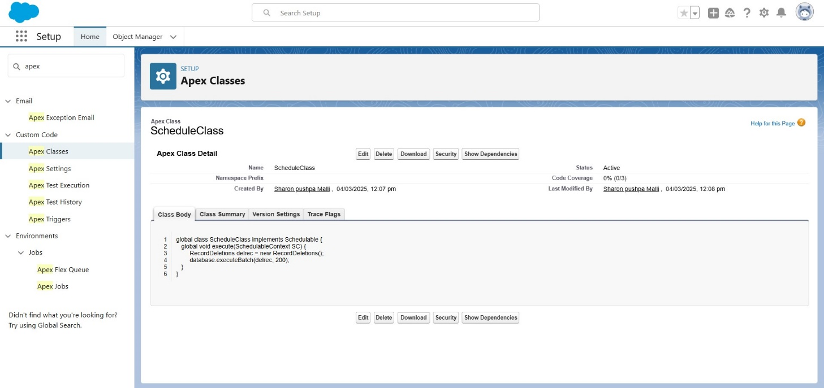

### Reports & Dashboards:

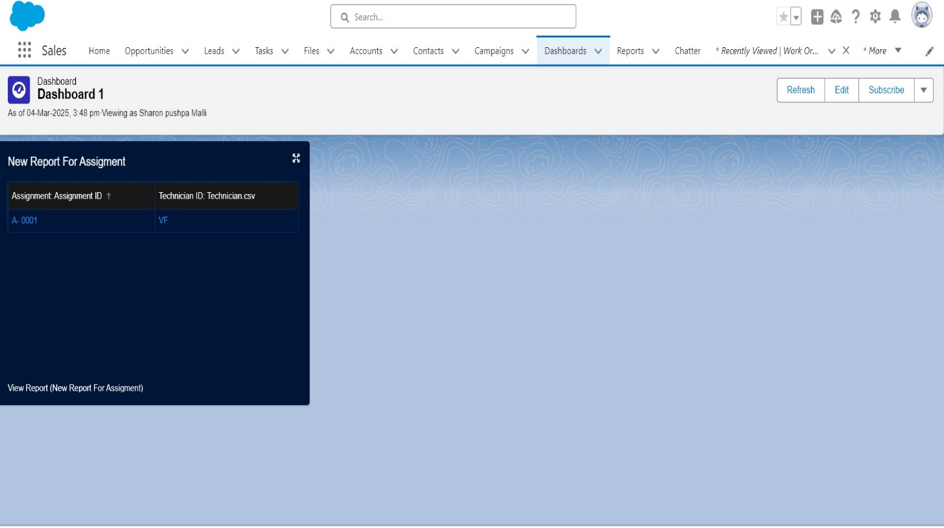

**Conclusion:**

The conclusion of field service work order optimization highlights the significant benefits of implementing streamlined processes, advanced technology, and data-driven decision-making. By optimizing work orders, organizations can enhance operational efficiency, reduce response times, minimize costs, and improve customer satisfaction.